|  |
| --- |
| Capgemini |
| Orphaned AID 52 Allocation From Consumed iLPN or Invalid Remote Task |
|  |
|  |
| |  |  |  | | --- | --- | --- | | **Document Update** | **Updated By** | **Date** | | Created By | Netravati Sutar/Sindhooja | 05/05/2016 | | Reviewed By | Sabita Prasad | 05/06/2016 | | Reviewed for the change in scenario | Sabita Prasad | 06/06/2016 | |
|  |

|  |
| --- |
|  |

**Issue Description:** User is unable to finish the remote packing process for the oLPN as tote is coming invalid.

***Orphaned AID 52 Allocation from Consumed iLPN or Invalid Remote Task***

**Severity:** Medium

**Description:** An email will be received from user saying that “I am trying to finish the remote packing process on this oLPN 00000197181429294739 so I can control G but the tote # 970900391313 is invalid”.

OR

An SCI alert will be triggered saying “SCI has detected one or more orphaned allocation records (AID 52). Tote has been either De-Allocated, Consumed, or Cancelled. Please recreate Tote to match below records, then run Change Control to update Tote's LPN_FACILITY_STATUS = 64... Once complete, operations can Pack, Chase, or Short Order”.



**Mitigation Approach:**

There is a Manhattan case open for this issue.

**Step 1:** Run below SQL query which is given in SCI alert mail too and you

will get the problem carton number and tote number in result:

select aid.cntr_nbr, im.item_name, im.item_bar_code, aid.batch_nbr, aid.carton_nbr, aid.qty_alloc, aid.mod_date_time

from alloc_invn_dtl aid, lpn l, orders o, item_cbo im where l.tc_lpn_id = aid.cntr_nbr and aid.tc_order_id = o.tc_order_id and aid.item_id = im.item_id

         and aid.invn_need_type = 52 and aid.stat_code = 0

and l.lpn_facility_status <> 64 and o.order_type = 'EC';

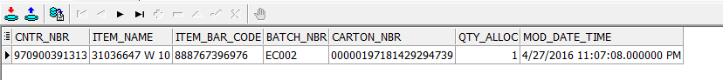

When you check, the tote will be in consumed or cancelled status but allocation will be open against that tote.

To fix this we need to Re-create iLPN with correct Item / Batch / Qty and change iLPN Status back to 64

Now check the tote and carton status by using below queries:

1. select * from lpn where tc_lpn_id='970900401505' and inbound_outbound_indicator='I'; --95

If it is in 95 status recreate the ilpn in RF

1. select * from lpn where tc_lpn_id='00000197181431415078' and inbound_outbound_indicator='O'; --15
2. select lpn_detail_status,batch_nbr, initial_qty, item_name from lpn_detail where lpn_id='44827144';

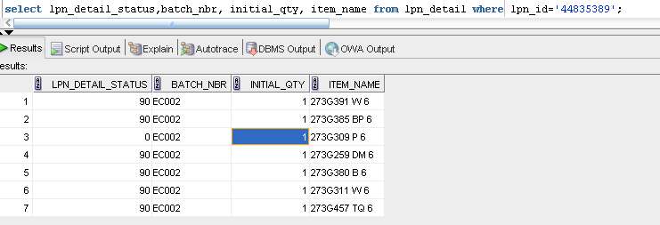

Note:

1. When you Check the qty,item and batch nbr exactly it should match with the SCI alert.(Take the lpn_detail_status “0” line and cross check) then proceed with recreation of ilpn.
2. Suppose if the tote is already in 10 status in inventory not put away go and check the item for that tote, if not matched with the given item add the correct item name,batch and qty and remove the default one.

**Step 2:** Login to Putty and go to below path on Prod server:

cd /apps/scope/wms_12_prod/tools/bin

Type ‘rfclient’ and enter. 970900381311

Login in to RF with your WM UI credentials.

Go to option ‘4.Inventory’ and then option ‘1.Create iLPN’

NOTE: You need to just put the number and press enter to select that option.

Accept whatever default Item is assigned, as we cannot control this part:

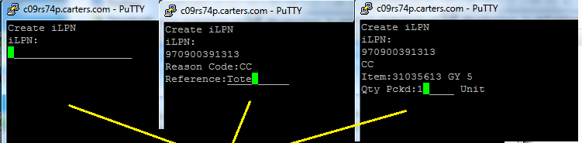

Note: When your entering qty pckd check the initial qty in lpn detail table and enter

**Step 3:** Once you create iLPN it will go to 10 status

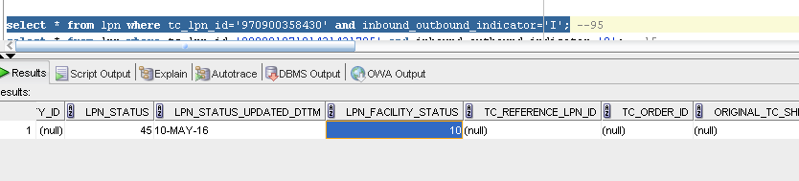

**Step 4:** Go to **“UI -> iLPN”**

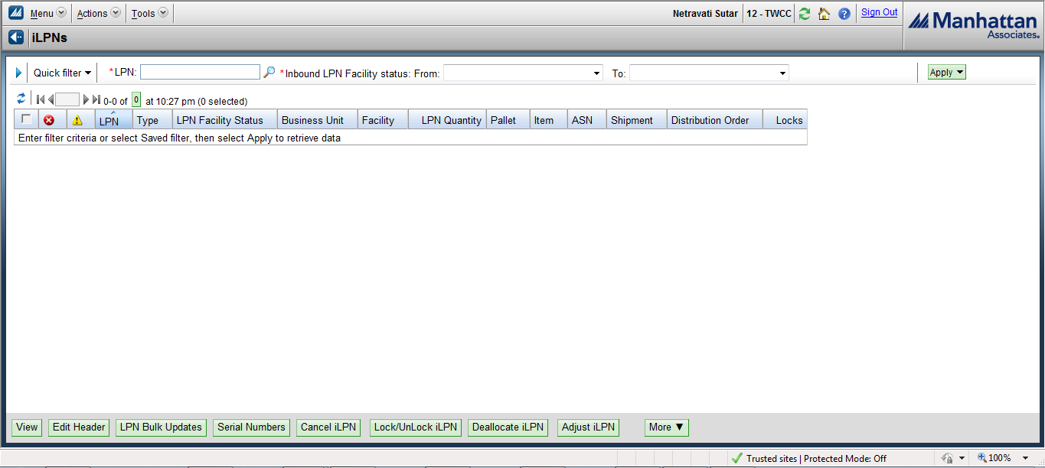

**Step 5:** Search for Tote just created in RF and select option **“Adjust iLPN”** at

the bottom**.**

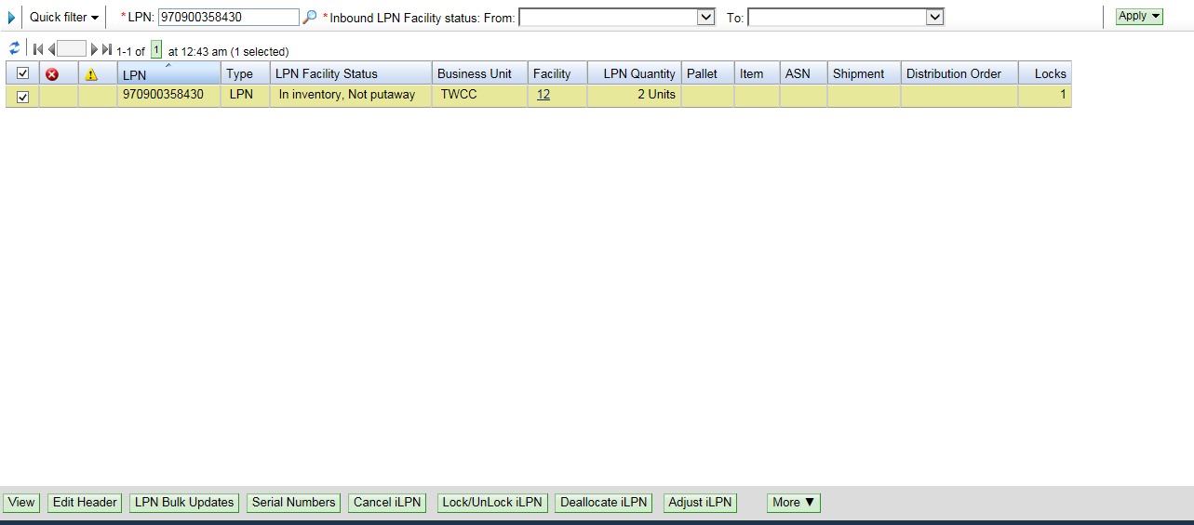

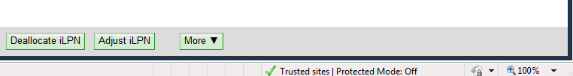

**Step 6:** If the correct item, batch and quantity is not added by default while

Using RF “Create iLPN” then add the correct Item / Batch / Qty as given in SCI Alert and save.

Sometimes you may get two items for one tote so you need to add both the item

Once you’re done with the corrected item again go back and click on adjust iLPN now you need to remove invalid item for the tote.

**Note:** If you don’t have invalid item just leave.

**Step 7:** Verify that end result matches SCI Alert exactly by iLPN Number, Item,

Batch, and Allocated Qty as shown below:

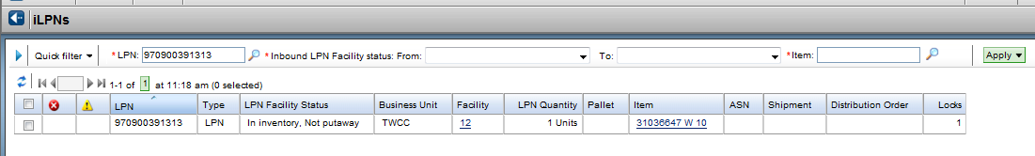

**Step 7:** Execute change control tochange **‘iLPN’** status from **“10 to 64 (Allocated and Pulled)”,** using below query:

**Update lpn set lpn_facility_status = 64 where tc_lpn_id in (‘#’);**

**Step 8:** Notify operations that Tote has been recreated and can be used to either “Pack”, “Short”, or “Chase” Carton.

**Note:** The key here is to make sure the Tote is created and matches the

Allocation records exactly, before we run the change control changing the tote

status back to ‘Allocated and Pulled’.

Below attachments are the CCF for the same.



